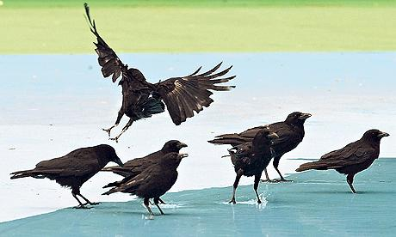 | Community Rights  Of  Way  Service
White Ribbon House, 1, New Road, Mytholmroyd, HX7 5DZ
Website http://httpwww.crows-coop.co.uk/
Email crows-coop@outlook.com
Consultation paper on stile design
These proposals are based on feedback from people who often have difficulty with stiles because of problems with hips and balance or their height. They also incorporate British Standards on stile design which have recently been updated.
British Standards say that no new stiles should be put in, only gates. Most of CROWS work is repairing stiles and the resources for replacing them with gates is not there. Our aim is therefore to make sure that whenever we repair a stile, wherever possible, we work to agreed standards that make them more accessible to walkers.
There are four main problems with stiles:
- The height between the ground and the step (sometimes due to erosion)
- The height between the step and the top rail (including the need for a second step)
- The width of the top rail
- The lack of a (suitable) grab post
The aim of this paper is to consult with people who have expressed difficulties as well as CROWS volunteers who repair stiles.
It doesn’t deal with standards of materials and the quality and method of construction.
Please send any comments or observations to the email address above.
Please feel free to pass on this email to anyone you feel might have an interest in the issue.
Thanks
CROWS team
STILE DESIGN BASED ON BRITISH STANDARDS AND FEEDBACK

Grab post on the side of the highest step, either fixed to stile post or stile post extended. Top rounded  Height above top rail 20 – 28 inches (500-700mm)  Max height from  top step to top rail 16 inches (410mm) | 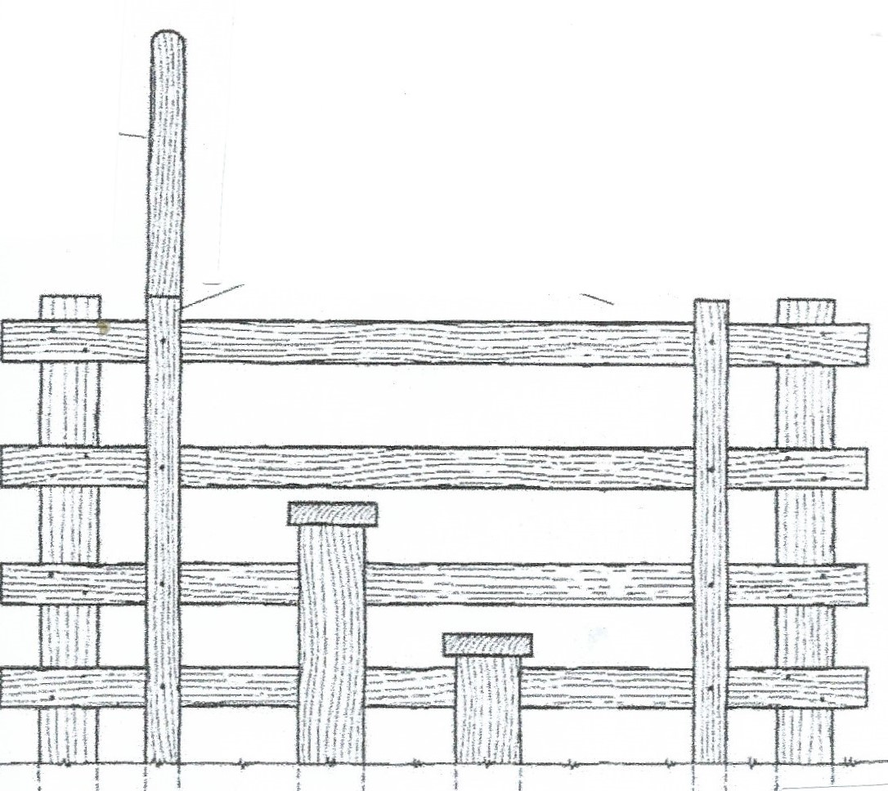 | Height between  first and second step 12 inches (300mm)  Height from ground  on to first step  12 inches(300mm)
Width of treadboards
4-5 inches (120mm)

Width of whole stile 30 inches (750mm) (not specified in standards but particularly important for walkers with hip limitations)

