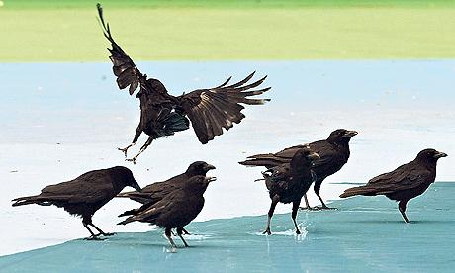 | Community Rights  Of  Way  Service
White Ribbon House, 1, New Road, Mytholmroyd, HX7 5DZ
Website www.crows-coop.co.uk/
Email crows-coop@outlook.com
Blog www.communityrightsofwayservice.blogspot.co.uk/
Facebook www.facebook.com/crowspaths

2017-18 Annual Report

Work carried out

The major project this year has been working with National Trust volunteers to refurbish all the published paths in Hardcastle Crags. These had fallen into a state of disrepair and needed upgrading prior to the publication of a new walking leaflet.

Our other work mainly came from an increase of reported issues through our new on-line reporting system. We also had several requests for improvements to routes used for walking events or for published walks.

The basic statistics for work carried out in 2017-8 are:

- The length of existing routes repaired was 185.4 km
- The length of new routes created was 3.5 km
- The number of way-marks put up was 526
- ﻿The number of steps installed or repaired was 230

The bar charts on the next page give a more detailed breakdown of the types of jobs we have done and the places where we worked
Types of work
This gives an idea of the range of work we do, the figures represent the number of tasks completed.
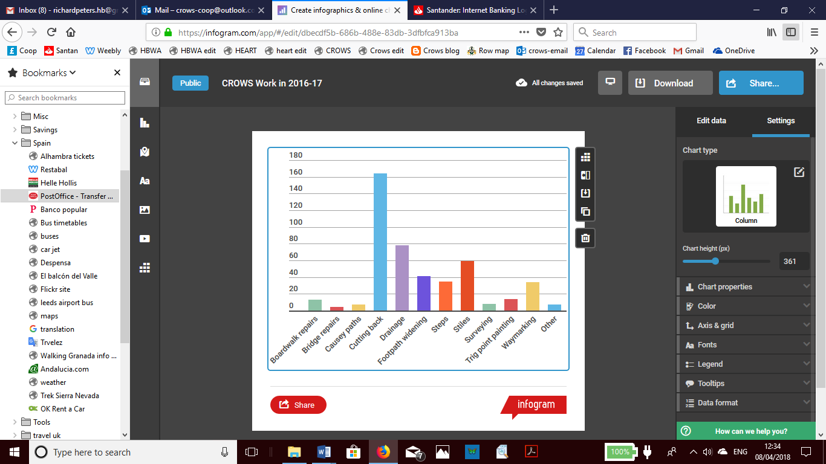

Where we worked
This bar chart gives an idea of the locations of work parties around the area.

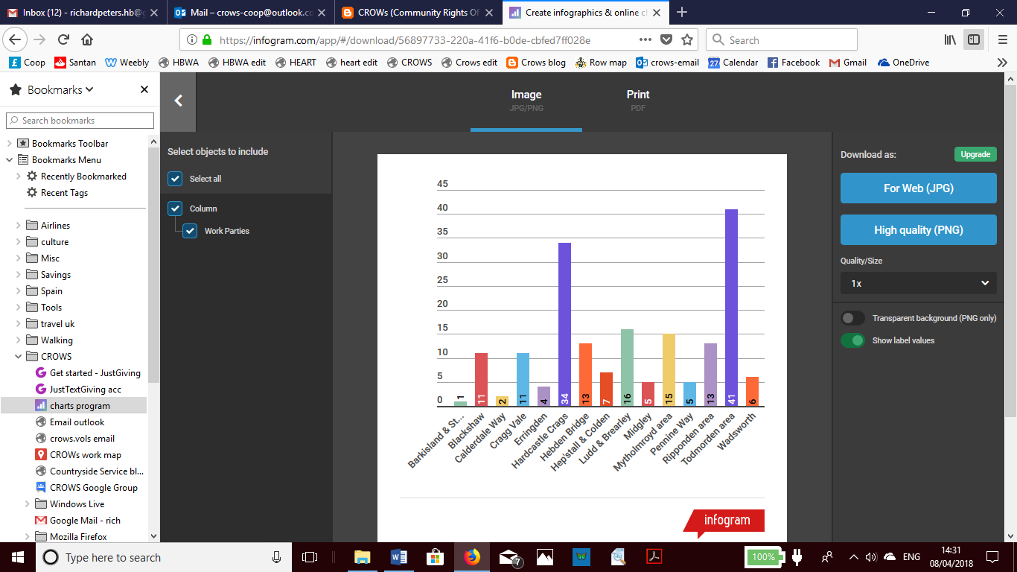

Some significant completed projects
Much of our work is routine (cutting back vegetation, sorting out drainage problems, fixing wobbly stiles), but during the year we have taken on a number of larger projects, some of which are shown here.

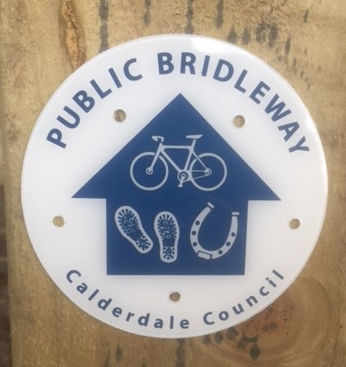 | 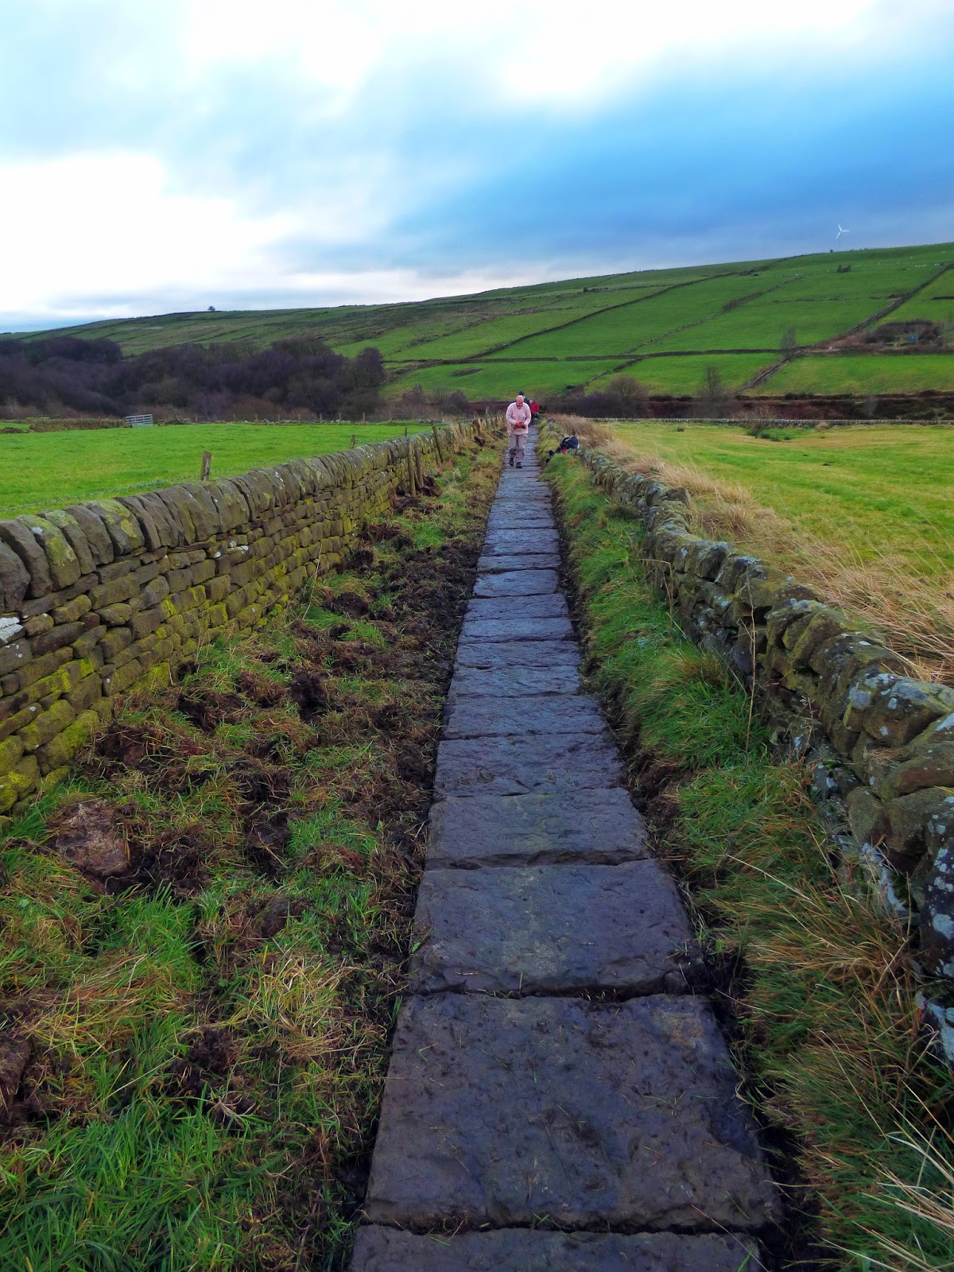
Bridleway waymarking project covering the whole area – to help the many mountain bikers who are unsure about which routes they may use. | The flags uncovered on the Pennine Way at Colden (before we started there was only a thin strip showing).
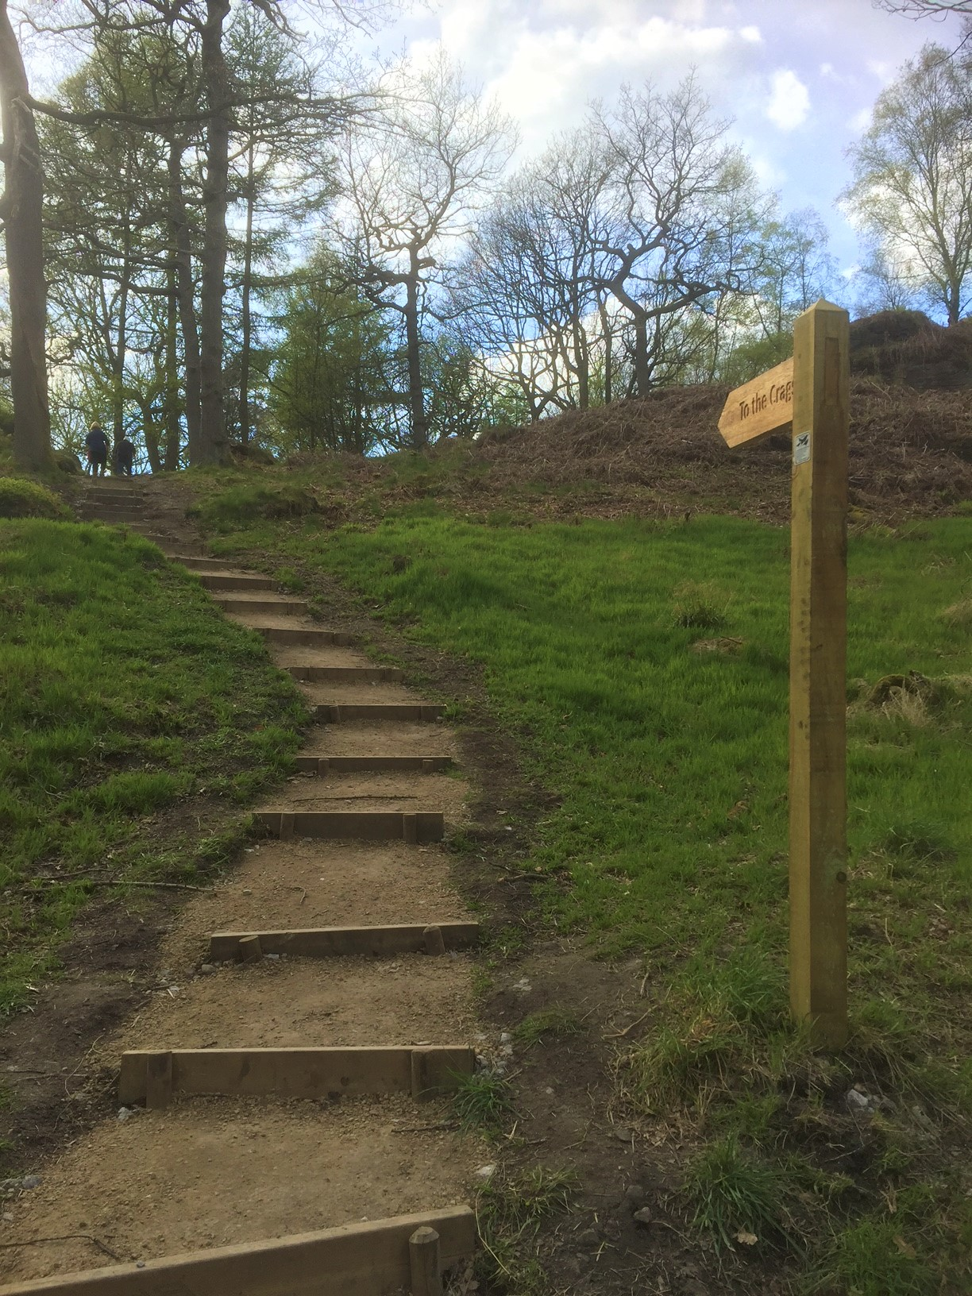 | 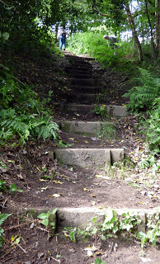
The new steps up to the top of the Crags – answering the common question “Where are the Crags?” The route is already very well used by locals & visitors. | Daisy Bank; uncovering this path that is well used by the local community at Mytholmroyd. There is still a lot to do on this route in the coming year.

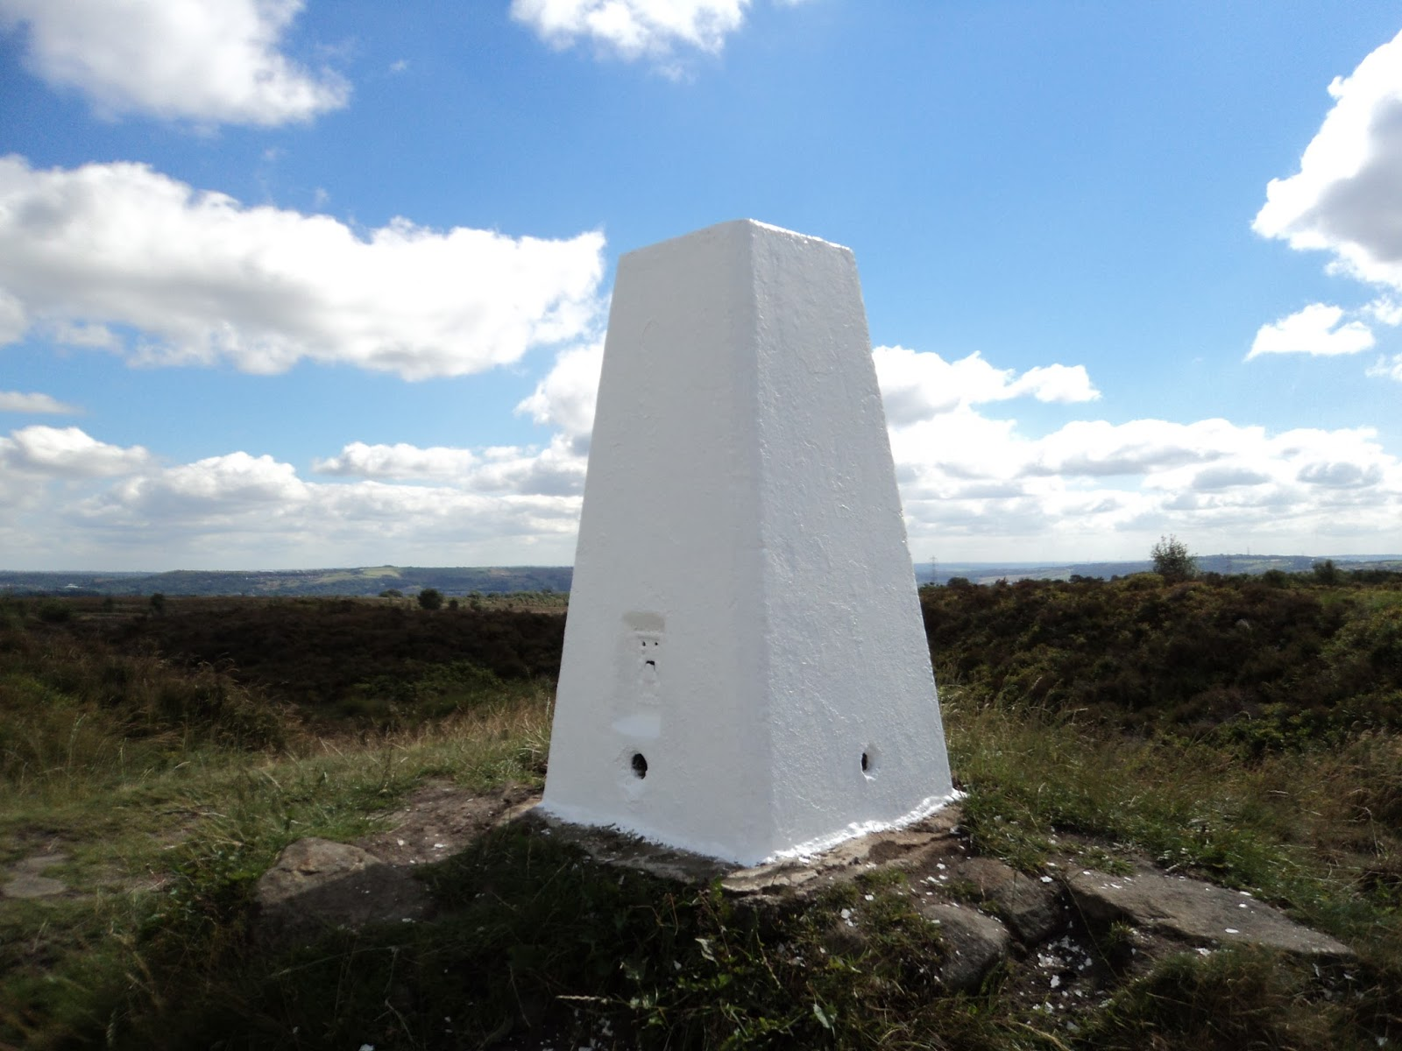 | 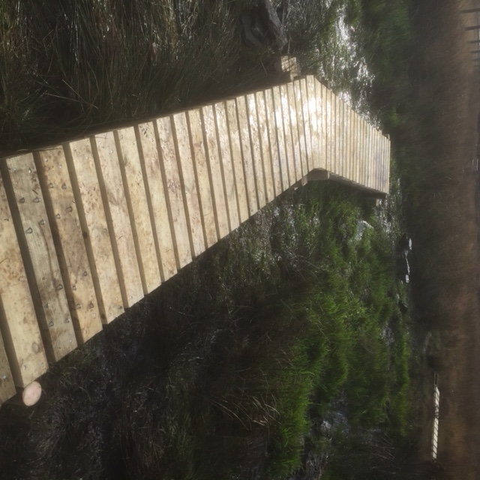
One of the newly painted trig points.  This one is at Norland Moor. Thirteen trig points in all; a very satisfying project. | Two lengths of boardwalk put in to open up an impassable path at Slade, Wainstalls.

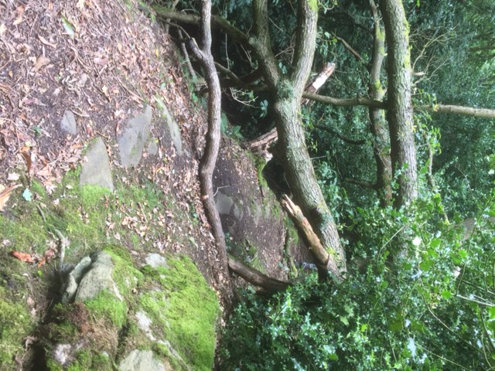 | 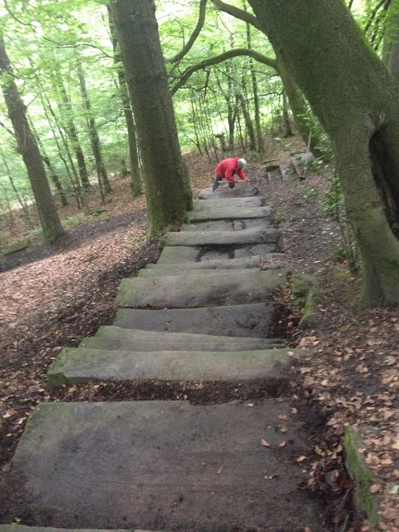
One of the many fallen trees cut up and removed (this one in Brearley Woods) often with the help of tree surgeon Ian Clarkson and his chainsaw. | Clearing of the old stone steps leading down to the mill at Kebroyd, Ripponden (part of the Sam Hill e-Trail) – sometimes our work feels more like archaeology.

One of the other pleasing projects was to deal with several big problems on the path from Lumb Falls to Midgehole – it is already proving to be a popular walking route.

There are many more photos of our work on our blog (address at the top) where we record the work of every work party. You can find out what we have been doing in your area by using the labels under places worked.

Financial support for projects
Although we receive no regular funding, organisations and individuals have generously supported our work this year:

- Calderdale Highways for several jobs that the public had reported to them
- Calderdale Long Distance Walkers Association for work on the annual Hebden event route
- Cornholme Xmas wreath making group for the repair of two significant paths in Cornholme
- Erringden, Heptonstall and Wadsworth Parish Councils for work on local paths
- Hebden Bridge Walkers Action for waymarking and repairing the routes for their new publication of ‘Walks to Wadsworth’ and the ‘Pennine Way Loop’
- Bronte Society for fixing problems on the Branwell Bronte route
- Hebden Royd Town Council for work on several paths in the area
- Ripponden Ward forum for several projects due to start in 2018-9
We also received an increased number of individual donations e.g. several for the trig point painting and a large donation to fund the boardwalks over Erringden Moor.
There has been an increased number of individual donations perhaps because we have made it easier to donate by introducing Just Giving.

Other support
- We are very grateful for the expertise and crucial guidance from Calderdale Highways officers.
- We continue to have use of the White Ribbon premises in Mytholmroyd which provides a great base for our work.
- CALVAG continue to provide an excellent service, responding to all our requests, sometimes at very short notice.
- We couldn’t do without Terry Nash, Alan MacDonald & Graham Ramsden who help us with our website, blog and Facebook page.

- Thanks to Elaine Ramsden for making sure our accounts all balance.

- Amy Gault from Splat training has provided several first aid sessions for us.

Volunteers
- We have been able to pay expenses to volunteers throughout the year.
- We recruited two great new members who have completed the induction process. We have two people in the pipeline and having revamped the way we recruit new people, we are now working on better material for attracting new volunteers.

Organisation
- First Aid training has been completed thanks to Amy Gault at Splat training.
- We now have an on-line system for reporting problems that is working well. The telephone report line has had a low number of reports so has been scrapped.
- Thanks to Frank H and Gerald, our depot at White Ribbon has never been so well organised.

Profile
- We received a fair amount of press coverage throughout the year. We also developed a good relationship with Valley Life and Go Local magazines.
- The website has been maintained and is updated regularly. It is now also used to make available all of our policies and procedures, saving a lot of time. About 5000 users visited the site during the year.
- The Blog has been further developed during the year and forms a unique public record of our work. The blog was visited 8,000 times during the year, a significant increase.
- The Facebook page had a reach of 15,000 people with over 250 regular followers. We have successfully used Facebook to rally help and support for some projects.
- We have developed materials for group talks to promote CROWS.

Finances
We start 2018 -19 with a balance of free reserves of over £2000. This amount will provide enough funding for the first four months work in 2018.

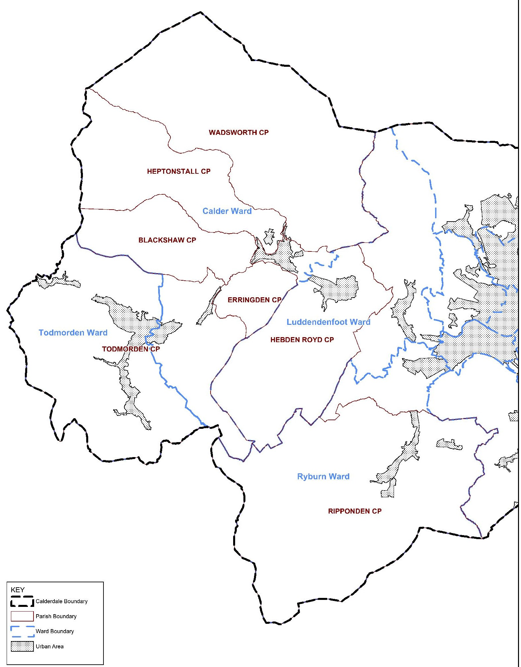
Where we work

