The wording on the board has to be kept at a minimum so that people read it. There will be a QR link to a web page for further information.
The final wording (and layout) will be agreed by a group of Todmorden Town Councillors.

Welcome to Gaddings Dam
The location
The dam is situated above you in open access moorland which is home to internationally important ground nesting birds
History
Gaddings Dam was built in 1833 to supply water to the mills of Lumbutts below, but became disused when the mills began to use steam power
By the 1960s the reservoir was empty, but a few years later the outflow was blocked allowing the dam to slowly refill. It took two years to fill
In the 1970s a local water and reservoir antiquarian bought the dam to preserve it
In 2001 the dam was to be drained due to its poor condition and safety issues. It was rescued by a group of local people who bought the dam, repaired it, and now continue to maintain it to the standards required by the regulations.

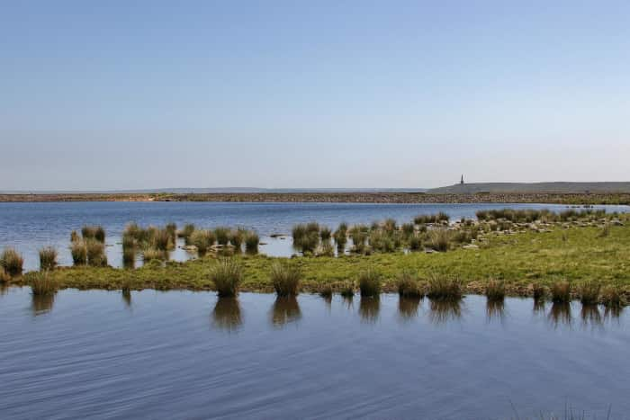
Image © Tessa A Kerr.
Copies of this photo and others are available from www.tessakerrphotography.com

Follow the sign-posted paths up to the dam
There is no road to the dam
There is a steep scramble up to the dam but it has become very eroded and very rough and slippery (especially coming down). There have been two serious accidents on this route resulting in fractures and countless numbers of skin scrapes.
Use the signposted paths
Two paths are very well sign-posted so you can’t get lost. They provide an easier and gentler route and are fine for children. Both paths are marked on the map

The paths may take a little longer but they are safe and pleasurable to walk
- The path via the famous Basin stone outcrop will take you about 40 minutes
- The scenic path via Jail Hole will take you about 60 minutes and has spectacular views of Stoodley Pike and Todmorden
Because of the challenging terrain, both paths will be very difficult for wheelchairs or buggys.
THE MAP WILL BE MUCH SIMPLIFIED
You are here
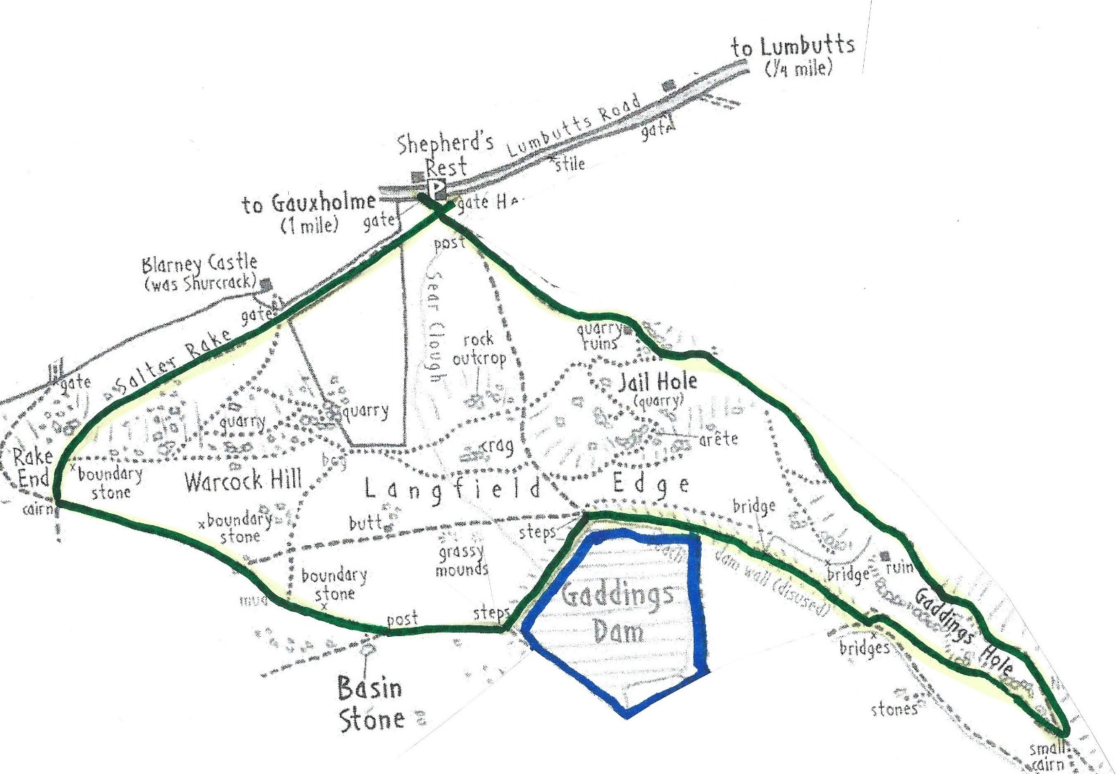

Before you set off
Check where you have parked.
You can park in the layby by this board or on the road (tuck your car close to the wall and fold in your wing mirror), but…
Do not park on any of the white lines.
Buses, farm vehicles and emergency vehicles use this road. If they cannot pass your car, you will be deemed to have obstructed the highway and will be liable to a fine. A white line indicates access is needed or it is a passing place. Parking is monitored, especially at busy times
Do not park in the Shepherds Rest car park.
This is only for customers and it is actively managed. If you park there, you may well be clamped or blocked in by other vehicles
Park and Ride
At busy weekends when no parking may be available, we suggest visitors park in the centre of Todmorden and use the half hourly T6/T8 bus services (or the hourly service from Lob Mill car park - OL14 8SR). See bustimes.org for times. JB Taxis at Todmorden railway station (01706 814494) are reasonable and reliable
Take some wind proof clothing
The dam is very exposed and is usually colder and windier. If it is sunny, you may not realise that you are getting burnt, so take sun cream and a hat
While you are at the dam
Be very careful swimming
- If you are not an experienced cold-water swimmer, just have a paddle. The water temperature is much colder than you might expect
- The dam has an average depth of 2 metres and the bottom is very rocky and uneven
- There is no life-saving equipment at the dam
Dry moorland is a great fire risk
Please don’t smoke or use barbecues. Moorland fires kills wild life and the moorland takes many years to recover
Toilets
There are no toilets or sheltered places at the dam
Take your litter home
There is no provision for rubbish collection, so take a bag to take it away
Keep Dogs under control
The moorland is a site for rare moorland birds that lay their eggs on the ground and there usually cows and sheep grazing nearby. You should always have your dog on a short lead.
More Info about Gaddings Dam and the area
Todmorden Information Centre has more information about Gaddings Dam, the moorland and other places to visit and walk in the Todmorden area
Contact 01706 818181 visittodmorden.co.uk + QR code
QR code leads you to a visit Todmorden webpage which link to paragraphs and links:

FAQs

History of Gaddings Dam gaddingsdam.org

Background to the Site of Special Scientific Interest (for ground nesting birds and blanket bog) which is managed by the freeholders of Langfield Common

Walks in the area todwalkers.org.uk

Other places to visit – eg Bridestones, Stoodley Pike etc

Friends of Gaddings Dam Tod Town Council logo

