Treatment for bleeding

Sit or lay the casualty down – this is to prevent them from falling if they become dizzy.
Examine the wound – can you see where the bleeding is coming from? Is anything in the wound?
Pressure – Apply pressure to the wound – press hard using a clean cloth for 10 minutes.

(those who have done first aid before may have heard about elevating a wound – after the 2015 Resuscitation Council review it was decided that the impact of elevation on a wound is negligable, pressure is by far the more effective means to manage bleeding )

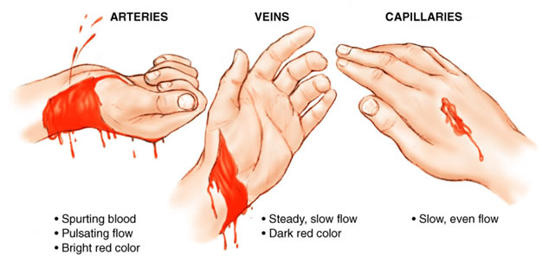
There are 3 types of bleed: Arterial, Venous and Capillary. For the first aider all that they really need to know is: How serious is the wound?
Is there a large amount of blood loss?
Difficult to determine depending on the surface the blood falls on but if it looks like a lot of blood it probably is – call 999.
Is blood squirting from the wound?
Any pulsating flow indicates that an artery or even a large vein is open, these blood vessels are under pressure and therefore a lot of blood can be lost – call 999.
Can you control the bleeding by applying pressure?
Bleeding should come under control with pressure within 10 minutes if it does not slow call 999.

Infection control
One of the main factors to consider with a minor bleeding scenario is that of infection. Consider both keeping the wound as clean as possible and preventing any cross infection between the first aider and the casualty. When dealing with any first aid situation we should be wearing gloves. Note that it is rare anyone injures themselves next to the first aid kit. Get the casualty to apply pressure to the wound themselves using any relatively clean cloth, tee shirt etc while somebody finds the first aid kit and you can get the gloves on.
Smaller wounds
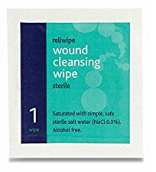
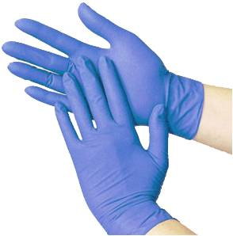
All smaller wounds should be cleaned using either warm tap water or sterile wipes. Once the wound is clean it is important to cover any open wound to prevent infection. This extends to even the tiniest wound such as where a splinter has been removed!! This may seem OTT but please consider the environment you are working in.
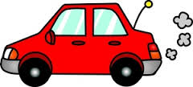
Sterile wipes are in the CROWS first aid kits and are intended to be single use. One wipe works from the middle to the edge of the wound and is discarded. Another, clean wipe works the other half of the wound. If the wound is large and is clearly going to need medical attention don’t waste time cleaning just get them to A&E.
Please consider; when taking someone to hospital you should not be driver and first aider. As first aider you should be able to travel in the back giving your full attention to the casualty. If you do not have a driver please call a taxi or ambulance.
Dressing a wound
For most smaller injuries, it will be necessary to cover the wound either with a plaster or with a bandage. Bandages should be in date and in air tight wrapper. These days they are usually integral i.e. the dressing is attached to the bandage and there are usually 3 sizes in most good first aid kits.
Anything embedded should NOT be removed – call 999 – The object may need to be immobilised using bandages. We will look at dressings and slings in the practical session. Please see below for treatment of shock.

Shock
When somebody loses a lot of blood or even when somebody sees an accident it is possible they might go into shock. This is where the blood pressure or blood volume drops so much that blood (carrying oxygen) is no longer able to circulate to the brain.
This is often visible when the casualty ‘drains of colour’.
Symptoms of shock, these move through stages.
- Pale cold and clammy.
- Shallow fast breathing, dizziness, cyanosis (blue lips).
- Deep breathing/yawning, aggression, lowered levels of consciousness.
- Unconsciousness.

Treatment for shock
- Do not give anything to eat or drink.
- Lie casualty down on a blanket or similar.
- Raise casualty’s legs above the level of the heart.
- Keep casualty warm.
- Call 999.
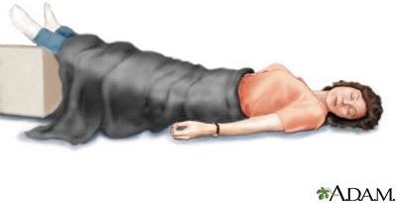
http://keckmedicine.adam.com

