INSTRUCTIONS FOR USING COUNCIL’S ON LINE MAPPING (2017)

This replaces previous guidance on the old system.

It’s often quite helpful to have a map with a job sheet to mark where exactly the work is. You can get quite detailed maps from the council website at https://www.calderdale.gov.uk/v2/maps/leisure

It probably makes sense to bookmark the website or put a shortcut on your desk top. When you open the maps site you get this screen.

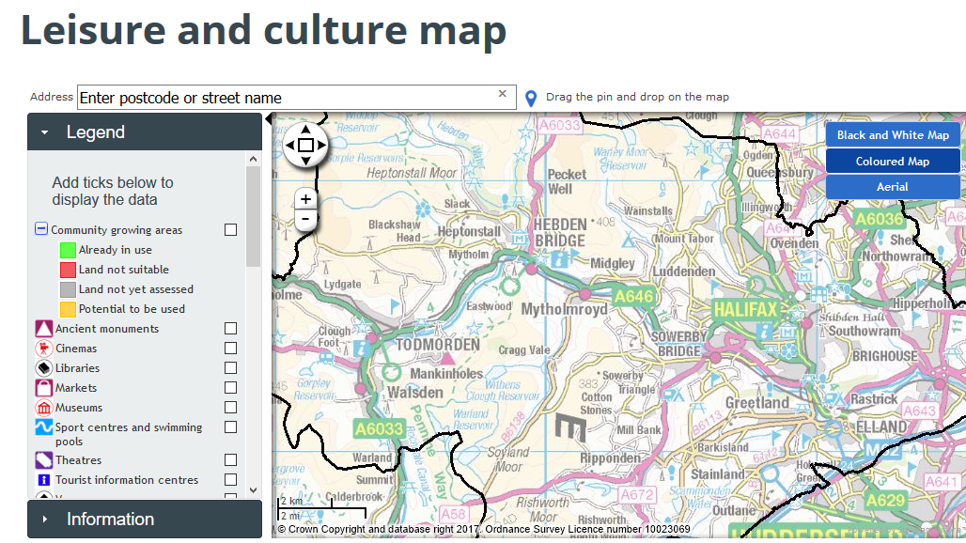

Before you start

If you scroll down the Legend list, tick box next to Rights of Way

You can select black and white Map (cheaper to print and easier to annotate a printed copy) or Ariel view

If you need to see more of the map, you can get rid of the Legend list by clicking on the little black arrow at the top right of the Legend List.

Manipulating the map

- You can blow it up using the + button on LHS of map – it will take you to a level of detail where the route of the path is totally clear.
- You can re centre the map by using the four < > buttons (or by depressing the LH button your mouse and dragging the image)
- If you click on the route of a path a pop up will give you the path number (eg Todmorden 026)

Just try the system out and if you get in a twizzle just shut it down and start again – it always takes you back to the screen above.

Printing off a copy

You need to take a screen shot i.e. the map that is on your screen. There seems to be several ways to do this…..

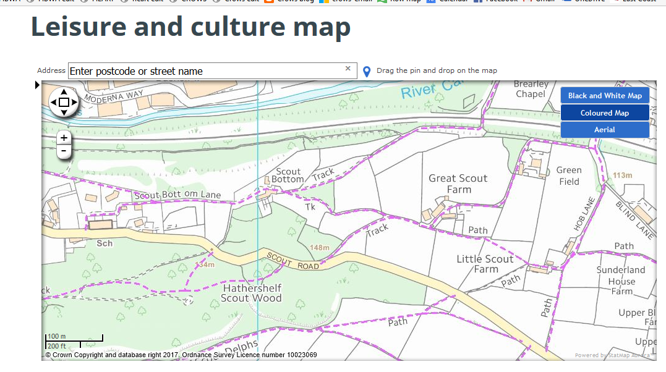
Screenshot ready for printing

SCREENSHOTS ON WINDOWS COMPUTERS

On your computer, you should have a key (usually top right) called PrtSc
Depending on your computer, do one of the following

- Press Control plus the PrtSc key together. You then need to paste the image into your usual word processing programme, you can then print the image
- Press Windows Logo Key plus the PrtSc key together - this puts a copy in your pictures folder, so you can print off from there.
- If your computer does not have the PrtSc button, you can use Fn key plus Windows logo key plus Space Bar

One of these should work!

SCREENSHOTS ON APPLE COMPUTERS

To get just a copy of the map window press cmd+P.
If you want the whole screen press CmdShift3

