BEFORE AND AFTER PICTURES FOR THE BLOG
Trying to align two photos in Blogspot (or Facebook) is not easy, but thanks to Graham, there is a pretty easy way to do it.
It involves downloading a small free Microsoft program (or app as they call it). It is quite intuitive to use, but there are some step by step instructions below.
Download the program
To download the app called Phototastic Collage click this link
https://www.microsoft.com/store/productId/9WZDNCRCWFTB
If you have an outlook or Hotmail account it will ask you for your password. If you don’t, contact secretary for login details.
Once in, the screen should look like this
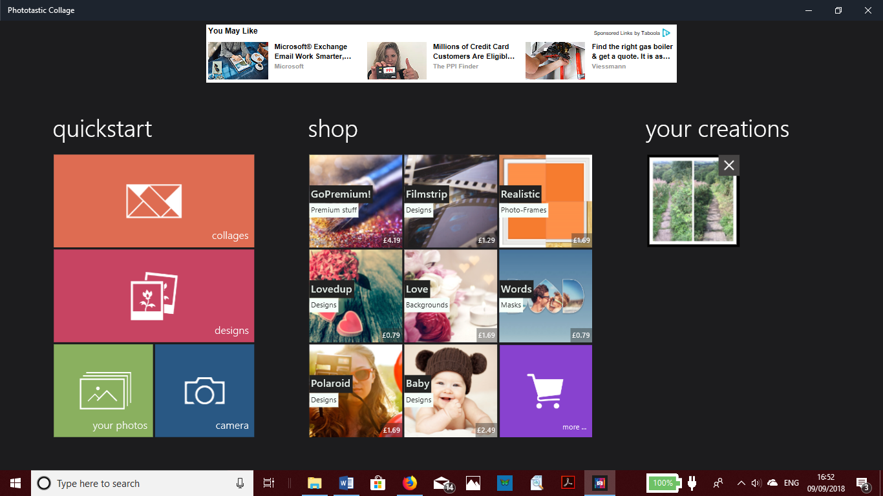

Select Collages under quickstart and you get this
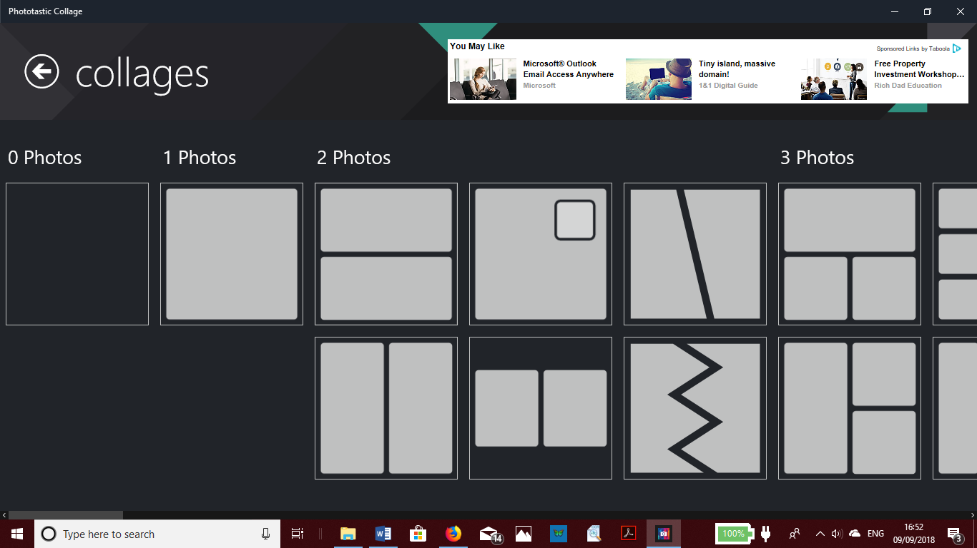

Under 2 photos, use the top one for landscape photos and the bottom one for portrait.
Once selected you get an option of choose variation – normally choose the top one (equal sizes). You arrive at this screen.
Press the + and you get the option of going to your photos
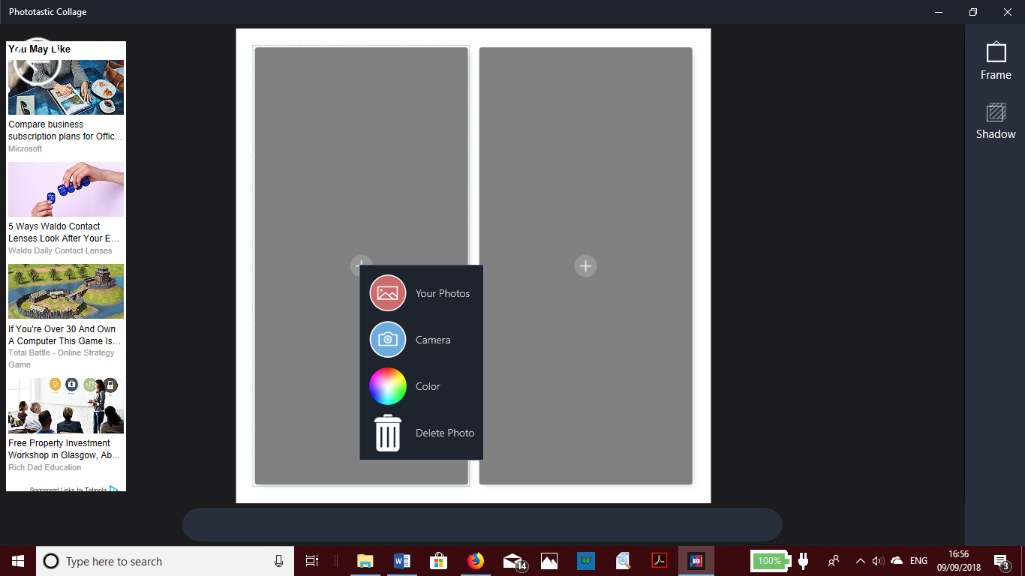
Pressing your photos will take you to your computer contents where you can browse and select the before photo. Once selected press Open which will load it into the left-hand panel.
Repeat for right hand photo.
If its ok, select save at the bottom of the tool bar on the right-hand side (if it’s not there, it might just be off screen).
If you want to try doing three or anything fancier, feel free!
Transferring it to the blog (or Facebook, or the website)
The blog will just see what you have created as a single photo, so you just insert it as you do usually (add media button).

