CROWS Handy Hints for installing Marker-posts
Final proof (FH) Aug 2019
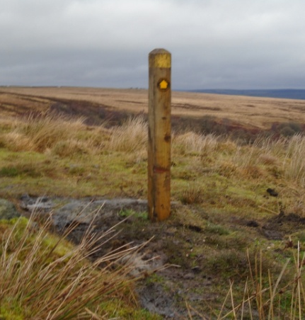
This is a standard 1.5 m x 100 mm x 100 mm marker-post.
It has a ‘shaped’ top which may be painted yellow.
It is vertical and aligned in the correct direction.
It has between 600 mm and 700 mm buried in the ground.
It doesn’t move when the top is waggled!
Fingerposts are double this height so you should aim for between 900 mm and 1.0 m in the ground (arm length may be a limitation of depth).

Equipment
Items you will need: Spade; bar; trowel; spirit level; club hammer; waymarks (+ hammer & nails);
first-aid kit.
Items you might need: Drill kit; panel saw; ‘deadmen’ (to prevent pull-out) e.g. 3 or 4 of 100 mm screw nails or 1 of wooden batten ~ 200 mm x ~ 75 mm x ~15 mm (+ suitable nails); stout wooden batten to act as a short ram; sack or plastic sheet; small bailer (if hole in wet ground).
What to do
- Cut a square of turf to mark the hole position. The width needs to be sufficient to accept the post and to have enough room to ram down the in-fill. Put the turf to one side where you won’t tread on it.
- Excavate the hole to a depth between 600 & 700 mm putting any stones and finer spoil in separate heaps (on the sack or plastic sheet if necessary). If you can only dig (say) a 500 mm hole then shorten the post proportionately.
*{If you are fitting ‘deadmen’, alternatives are:
i) a batten ( ~200 mm x ~ 75 mm x ~15 mm) nailed to one face at the very bottom of the post or
ii) screw nails (100 mm) fixed at an angle on 3 or 4 sides but these must be towards the very bottom of the post otherwise they will inhibit successful packing of the first layer of in-fill}.
- Position the post vertically and align it in the correct direction.
- Add in-fill consisting of small stones (up to ~40 mm diameter) mixed with soil for the first ~200 mm of the hole. This should be rammed-in very firmly using a bar (or wooden batten and lump hammer) and then rammed in some more! This is absolutely essential otherwise the rest your work will be wasted effort!
- Check alignment/verticality and adjust if necessary
- Gradually fill the rest of the hole using larger stones in conjunction with soil, each layer being rammed-in very tightly. Alignment and verticality should be checked as needed
*OPTIONAL: {To make the post more resistant to livestock and vandals, the following is an option: when the hole is about ¾ full, a pointed batten ~400 mm x 100 mm x 25 mm, can be driven diagonally (flush with a face of the post) into the side of the post-hole so the top end of the batten is just below ground level. The batten is then nailed to the post and any waste cut off before further in-fill is rammed in}.
- Fill the top ~75 mm of the hole with soil (trodden in firmly) and a layer of turf.
- Scatter any remaining debris and fix waymarks, as appropriate, to indicate the line of the RoW.
- The post should now be vertical, aligned in the correct direction and ‘rock-solid’.

IF THE POST MOVES WHEN YOU TRY TO WAGGLE THE TOP, THEN
YOU MIGHT HAVE TO DIG IT OUT AND START AGAIN!!

